

Applied Data science 1

Statistics and Trends Report



ABSTRACT: Python, a programming language, is utilized throughout this data science practical exercise that is being carried out here. To plot the graphs, we are basically making use of the various Python libraries, such as the matplotlib and the seaborn libraries. In this case, I make use of the values of the indicator column that have a greater number of observations in comparison to the other values since doing so will assist in accurately producing the graph. From the graphs we can understand that the world population having access to electricity has increased from 73.4% in 1998 to 90% in 2019.

*Student Name: Sravani Reddy Marramreddy*

*Student ID: 21061835*

Climate change data analysis based on World Bank data

Nearly 40% of electricity generated across the world is thermal electricity which involves burning of carbon products, which degrades climate. 3 decades ago, electricity was not accessible to some parts of the world, but now electricity is accessible to a much large population, which has risen the amount of electricity production and in turn increasing the amount of CO2 released into the atmosphere and is making the climate worse.

# Percentage of world population having access to electricity:

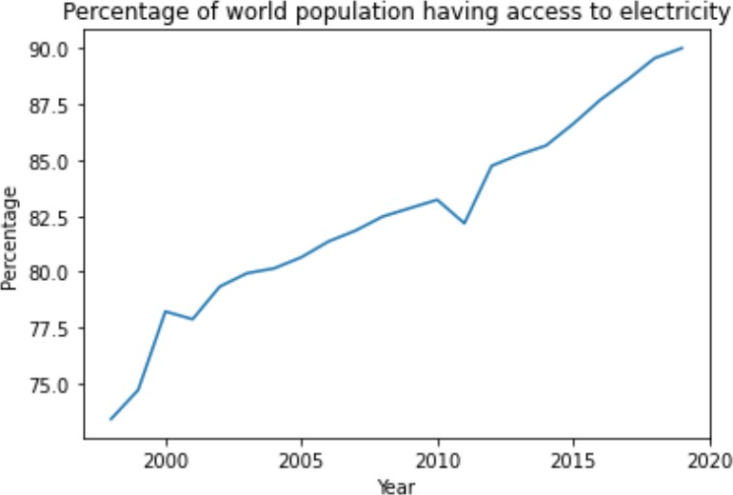

From this plot, we can understand that the world population having access to electricity has increased from 73.4% in 1998 to 90% in 2019.

# Amount of CO2 emission all over the world:

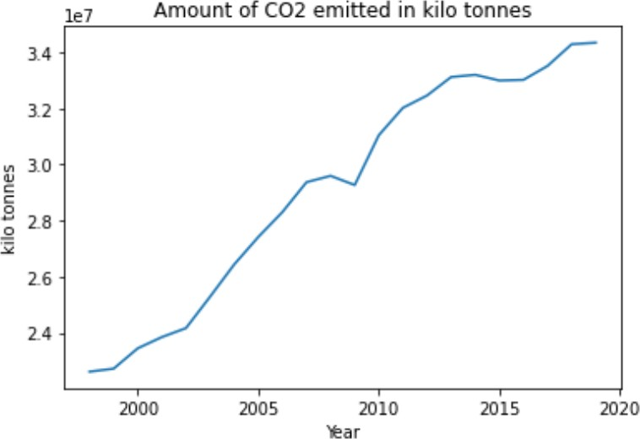

The above plot shows that the amount of CO2 emitted was 22613709 kilo tones in 1998 and it has increased to 34344006 kilo tones in 2019.

# The amount of CO2 emission and percentage of population having access to electricity data from 1998 to 2019:

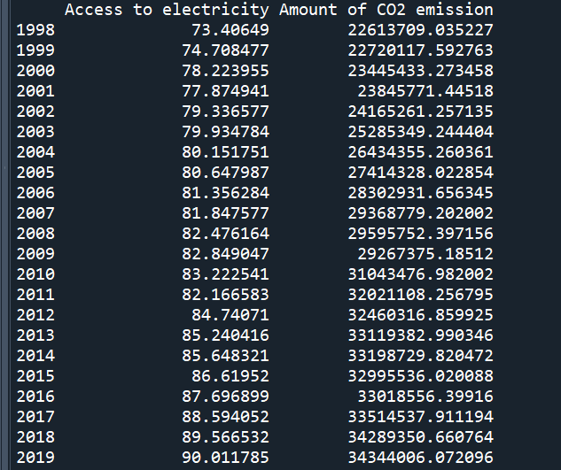

**Summary Statistics:**

The mean value of percentage of world population having access to electricity is: 82.56006326595075.

The mean value of amount of CO2 emitted is: 29202916.61567484.

The standard deviation of the world population data is: 4.477128880655251. The standard deviation of the CO2 data is: 4099702.1821198547

The correlation between the amount of CO2 emission and the percentage of world population having access to electricity is: 0.9439615842343759.

This high correlation establishes the fact that we should explore other forms of electricity production in order to save our climate.